COMHAIRLE CHONTAE LONGFOIRT

LONGFORD COUNTY COUNCIL

Corporate Affairs,
Aras an Chontae,
LONGFOIRT.

9u Meitheamh 2014.

To: Each Member of the Ballymahon Municipal District

A Chomhairleoir,

You are requested to attend the first meeting of the Ballymahon Municipal District to be held in Council Chamber, Aras an Chontae, Great Water Street, Longford, on Monday, 16th June 2014 at 4.00 p.m. to transact business, as set out on the Agenda hereunder.

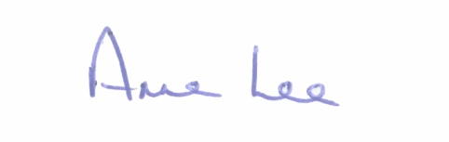
Mise le meas,

_______________
Anne Lee,
Meetings Administrator.

C L A R

1. Election of Cathaoirleach.

2. Election of Leas Cathaoirleach .

3. Fix date, time and venue of Ballymahon Municipal District meetings.

4. Consideration of Standing Orders in respect of meetings of Municipal District Members.

